**South Copeland Community Partnership - Community Forum Report**

This document provides a record of the Community Partnership’s second Community Forum held on 14 March 2024 at Drigg and Carleton Village Hall.

1. **Background**

The South Copeland GDF Community Partnership (CP) formed on 14th December 2021. An important role for the Community Partnership is to facilitate discussion with the community. Section 6.51 and 6.52 of the [Working with Communities Policy](https://assets.publishing.service.gov.uk/media/5c1a4be3e5274a46897da06a/Implementing_Geological_Disposal_-_Working_with_Communities.pdf) highlight the importance of community engagement activities and the need to “open up community participation through a wide number of channels.” It goes on to say that “One way of doing this could be to hold open public meetings of a Community Stakeholder Forum”.

In the 2023/4 Community Partnership Delivery Plan there was a commitment to pilot a Community Forum by the end of September 2023 - Quarter 2 of the financial year.

1. **Agenda &** **Format**

The format for the community forum was as follows:

* Chair’s introduction (15 mins)
  + - Introductions – who is here today from the Community Partnership/support team.
    - What is a Community Forum?
    - How it will work?
  + Three roundtable discussions (80 mins)

Attendees were spread out across 4 tables with 6-7 people per table. They were then asked to discuss three separate topic areas:

* Impacts (20 minutes discussion and 15 minutes feedback to the forum)
* Community Partnership (15 mins discussion and 10 minutes feedback to the forum)
* Your community (15 mins discussion and 10 minutes feedback to the forum)
* Wrap up (15 mins)
  + Next steps
  + Feedback
    - Come to CP meetings/engagement opportunities
    - Thank you

1. **Community Partnership Chair’s Introduction**

The Chair introduced the members of the Community Partnership and explained why they wanted to pilot a Community Forum.

The following extracts from the Working with Communities Policy were shared to help attendees understand why a Community Forum could be an important engagement/communications tool.

**6.51 The Community Partnership will need to engage the community over a long period of time. Getting people involved on any issue can be challenging. It will therefore be important to open up community participation through a wide number of channels.**

**6.52 One way of doing this could be to hold open public meetings of a Community Stakeholder Forum. The Forum could meet at regular intervals, giving the Community Partnership the opportunity to report on activities it has undertaken and the outcome of those activities. It would give members of the community the opportunity to raise questions and issues that they want addressed, which could then be fed into the programme of activities.**

The Chair clarified that the main function of a Community Forum is to allow the wider community to feed in their questions and concerns about possibly hosting a GDF, which in turn helps the Partnership decide on its Programme of Activities. The Chair reiterated that it is not a mechanism for monitoring public opinion or for discussing matters that fall outside the role of the Community Partnership.

The Chair finished his introductions by explaining how the Community Forum would work before moving into the roundtable discussions.

1. **Discussion 1 – Impacts**

This discussion on the potential impacts of a GDF was split into both negative and positive impacts. The questions below acted as a prompt. The feedback from each attendee’s table is below with photographs of the flip charts captured in the Appendices.

**If a GDF was built in South Copeland:**

* + **What do you think the negative impacts could be?**
  + **What do you think the positive impacts could be?**

**Feedback from Table 1 facilitated by John Sutton**

|  |  |
| --- | --- |
| Negatives | Positives |
| Drigg and Carleton parish already has a large nuclear footprint and the possibility of 2 more facilities – too small for all 3 projects | Long-term employment (as long as it is for local people) |
| Proximity to national park | Waste is already in West Cumbria |
| Increased levels of traffic through the village | We are contributing to the common good |
| Competition for the land from other nuclear projects | Community Investment Funding |
| Drigg village would be affected by:   * Pylon upgrades * Rail upgrades * Road upgrades | It’s part of a bigger programme – if we hadn’t led the way there wouldn’t be a programme. |
| Single access road into Drigg village | We can say no! |
| Headworks close to homes | Without a GDF, there would still be a problem to solve locally |
| Cumulative affect of waste projects | A major employer |
| NDA now own more of the limited land available | Provides a long-term solution |
| Much of the land that is available is SSSI | Opportunities for young people – colleges, universities, skills |
| Current ward boundaries don’t reflect the ‘community’ | Infrastructure upgrades – hospital, schools etc |
| Would fit better in the mid Copeland Community although concerns re mid community being happy to send the waste to Drigg |  |
| ToPS should be just the community with the headworks |  |
| The ward is not the community |  |
| Wherever a GDF is built, this community is impacted |  |
| You are currently getting an artificial community view |  |
| Impact of the construction phase |  |
| Shortfall of workforce |  |
| Worker complexes and the associated problems |  |
| Pressure on local services – doctors, dentists, schools etc |  |
| Impacts on tourism |  |

**Feedback from Table 2 facilitated by Maggie Cumming**

|  |  |
| --- | --- |
| Negatives | Positives |
| Massive building project | Jobs |
| Compulsory purchase | Money coming into the area (Contractor/worker spend) |
| Construction phase ongoing 10-20-30 years | Investment in local infrastructure |
| Headworks could be bigger than 1km2 during construction phase | Increase the population of the area |
| House prices could be affected, even at this stage due to house searches | 6th form centre of excellence |
| Proximity to where we live |  |
| Not just considering one national infrastructure project. Fighting it on all sides – SMRs, new nuclear plants |  |
| Impact on mental and physical health |  |
| Need to learn lessons from HS2 |  |
| How do we quantify? State of limbo/everything on hold |  |
| Public perception, people understanding what it is. How will affect the coastline? |  |
| People who are contracted may not want to live in the area, just come here to work. |  |

**Summary of discussion 1 - Impacts**

As detailed above, there was a lot of information discussed and recorded in the session on impacts of a GDF. The discussions can be summarised by grouping the points raised under different themes.

The perceived negative impacts of a GDF fell broadly into the following themes:

* Scale of nuclear projects in the area
* Transport/infrastructure
* Construction
* Community

The perceived positive impacts of a GDF fell broadly into the following themes:

* Infrastructure improvements
* Skills/employment
* Solving a problem

1. **Discussion 2 – The Community Partnership**

The second discussion was a wide-ranging discussion about the Community Partnership. The following questions were used as prompts for the discussion, participants were able to talk about any and all aspects of the Community Partnership.

The feedback from each attendee’s table is below with photographs of the flip charts captured in the Appendices.

* **What do you know about the Community Partnership and its role?**
* **What do you think it is there for?**
* **What information would you like to see/receive from the Community Partnership?**
* **How would you like to receive information from the Community Partnership? e.g. website, post, email, social, events, private conversation, online forum.**

**Feedback from Table 1 facilitated by John Sutton**

**Views on the Community Partnership**

* Developer weighted
* Members don’t have a strong enough voice
* Can’t influence policy
* Policy is clear
* It will go to fast if the community/CP don’t slow it down
* CP drives what the community wants from the developer
* It takes a long time to get information from the developer e.g. PVP
* CP should demand info from the developer
* Perception that the CP can’t do anything

**Feedback from Table 2 facilitated by Maggie Cumming**

**Views on the Community Partnership**

* It does nothing
* Assume it is independent
* Whole process is Mickey Mouse
* Doing level best for the communities
* Doing what government has thrust upon you
* Doing a good job

**How would you like to receive information from the Community Partnership?**

* Geology presentation was excellent
* Afternoon and evening events
* Advertise everywhere. Multilevel communication
* Website is good
* Need more info about events – housekeeping, food etc
* Ensure all reports are accessible and on the website (transparent)

**Summary of discussion 2 – The Community Partnership**

In summary the conversations about the Community Partnership was wide ranging with each table recording a number of different points as detailed above.

The main points that came across on multiple occasions were:

* Assumptions that the CP is developer led and the members don’t have a voice
* Recognition that members are doing their best for their communities
* There is still a lack of understanding about the role of the Community Partnership

1. **Discussion 3 – Your Community**

The final discussion was about the community and the following questions were used as prompts.

The feedback from each attendee’s table is below with photographs of the flip charts captured in the Appendices.

* **What are the main reasons that you like living in this community?**
* **What are the main challenges the community faces?**
* **What are your hopes and aspirations for your community in the future?**
* **What would you like your community to look like?**

**Feedback from Table 1 facilitated by John Sutton**

|  |  |
| --- | --- |
| **What are the main reasons that you like living in this community?** | **What are the main challenges the community faces?** |
| Property prices are low | No further education facilities (post 18) |
| Specialist job opportunities | Lack of educational choices |
| Job potential | Lack of job opportunities outside nuclear |
| Rural area | Lack of health facilities |
| Peace and quiet |  |
| Undeveloped |  |
| Small population |  |

**Hopes and aspirations**

* Drigg to be included in the National Park
* It remains as it is now but with better access to healthcare

**Feedback from Table 2 facilitated by Maggie Cumming**

|  |  |
| --- | --- |
| **What are the main reasons that you like living in this community?** | **What are the main challenges the community faces?** |
| Rurality | Lack of facilities |
| Remote | Cultural diversity |
| The people/characters | Transport |
| Environment – beaches, fells, nature | Hospitals – consultants and distance to travel |
| Heritage | Road network – vulnerability to flooding and accidents |
| Opportunities for making music – Arts out West etc | Education |
| Visit village halls – film clubs |  |

**Hopes and aspirations**

* Waste has to go underground so need to do something
* Could be a centre of excellence for renewables but direction of travel needs to be national
* Area needs to be more resilient – renewables, technology. Supporting small local sustainable businesses which would not impact on tourism

**What would you like your community to look like**

* Schools
* Hospitals
* Police when we need them
* Clean air
* Clean rivers
* Green fields
* Nature
* Worthwhile jobs
* Community
  + Social
  + Spiritual
  + Neighbours
  + Shared activities
  + Sports
  + Restaurants
  + Church Halls
* Local resilient communities sustained by local people

**Summary of discussion 3 – Your Community**

In summary the main things that people liked about living in the South Copeland community were:

* The natural environment
* The heritage and community
* Job opportunities

The main challenges that people thought the community faced were:

* Lack of facilities
* Transport

1. **Next steps**

The Forum finished with an update from the Chair on what would happen following the Community Forum.

The Chair confirmed that a report of the event would be produced which would include photos of all the flipcharts for openness and transparency.

The Chair informed the attendees that the Community Partnership were commissioning a report on the potential impacts (positive and negative) of a GDF in South Copeland. The output from the first discussion of the event on impacts would be fed into the scope for this report.

Finally, there was then an opportunity for participants to fill in feedback forms about the event. 15 people completed the feedback forms and photographs of them are captured in the Appendices.

**Summary of feedback forms**

Four feedback forms were received

|  |
| --- |
| **How did you find out about the event?**  Word of Mouth  Poster/Flyer  Social Media  **3**  Other **1** |
| **How would you rate the information provided to you today?**  1 (Very poor)  2(Poor)  3(Adequate)  4(Good) **2**  5(Very Good) **2**  **Do you have any feedback or comments.**   * Very welcoming non-threatening event. I have learnt such a lot. * I would encourage repeating this once headworks sites can be discussed. * More information in the nature of the meeting e.g. lecture, discussion, food. * Forum concept is very good |
| **Did you think the format of the event worked well?**   * It worked very well, small discussion groups feeding back to the whole room worked well. Hearing local peoples views was very interesting * Syndicates work well * Yes * Yes good opportunity to chat with others |
| **Additional Questions**   * Property Value Protection Scheme details |
| **Additional statements** |

1. **Deliverables**

The Community Partnership will review how the Forum has gone and consider any lessons learned before drawing up an approach to future Community Fora. It was clear that the attendees were very keen for more fora to take place.

**Deliverable – Community Partnership to consider approach to future Community Fora.**

The output from the ‘Impacts’ session of the Community Forum will be fed into the developing scope for the Community Impacts Report which the Community Partnership are in the process of commissioning from independent experts.

**Deliverable – Include output from the ‘Impacts’ session of the Community Forum in to the Community Impacts Report scoping document.**

**Appendix 1**

**Flip charts from discussion 1 – Impacts**

**Feedback from Table 1 facilitated by John Sutton**

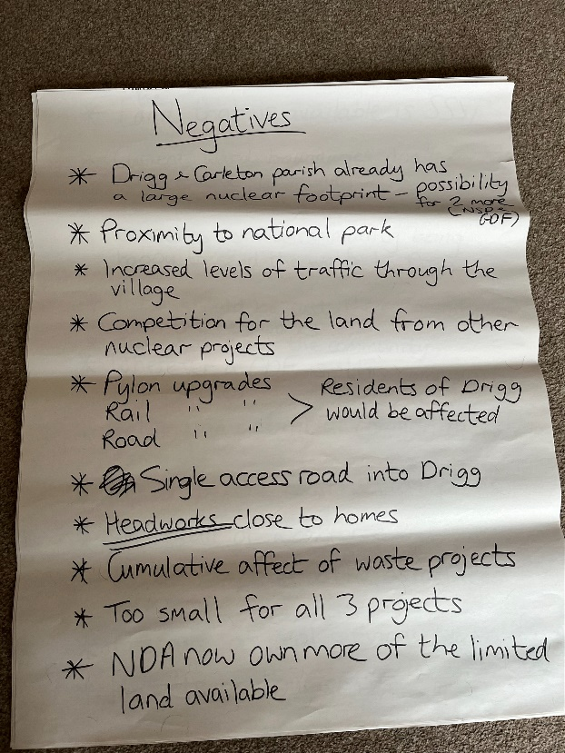 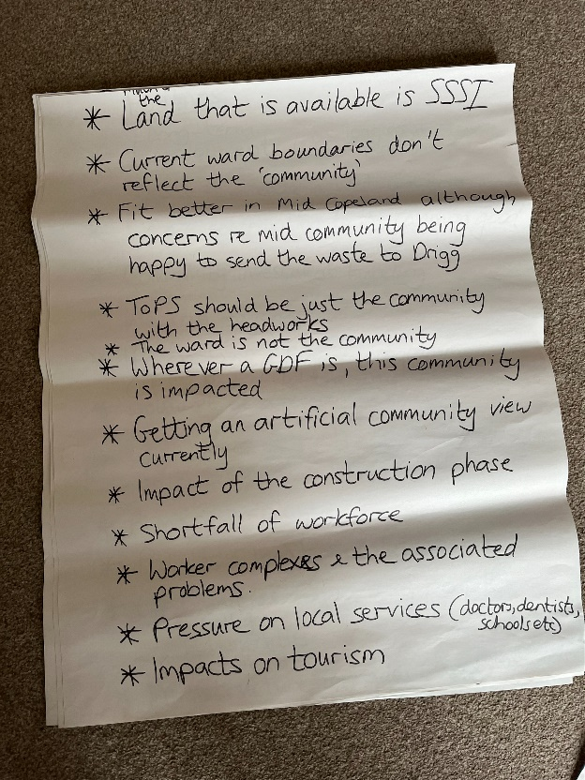

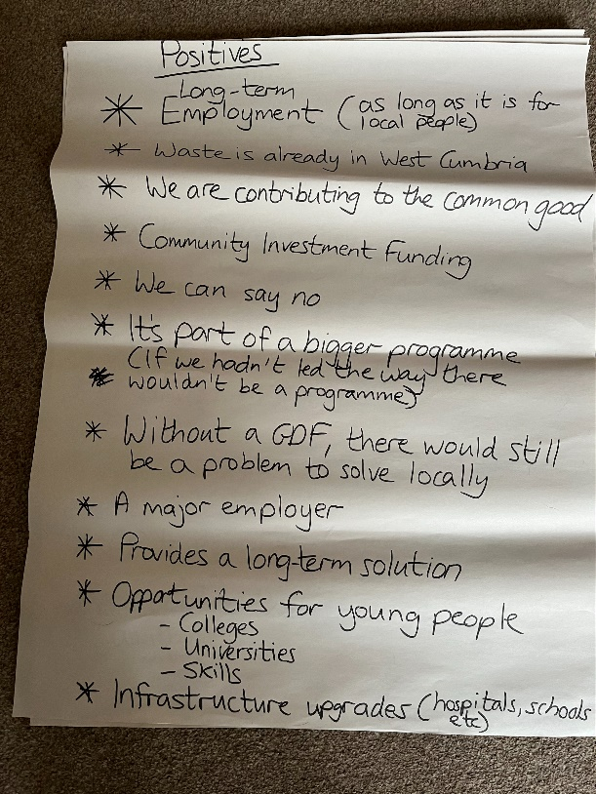

**Feedback from Table 2 facilitated by Maggie Cumming**

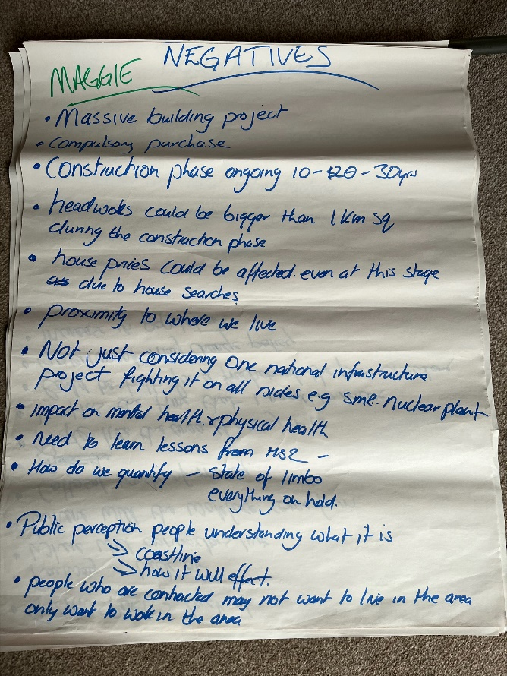 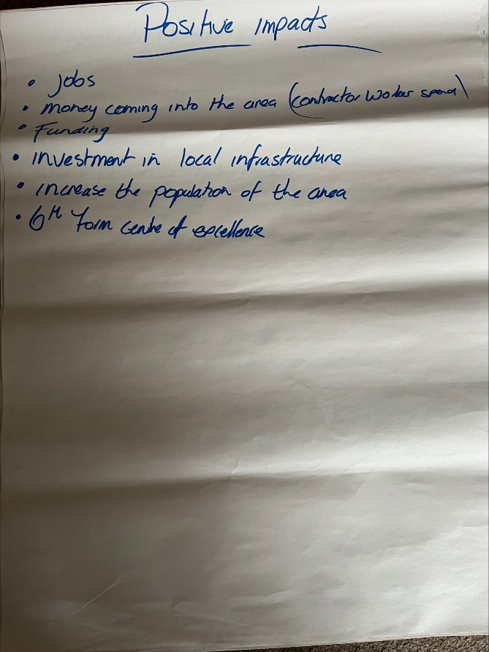

**Appendix 2**

**Flip charts from discussion 2 – The Community Partnership**

**Feedback from Table 1 facilitated by John Sutton**

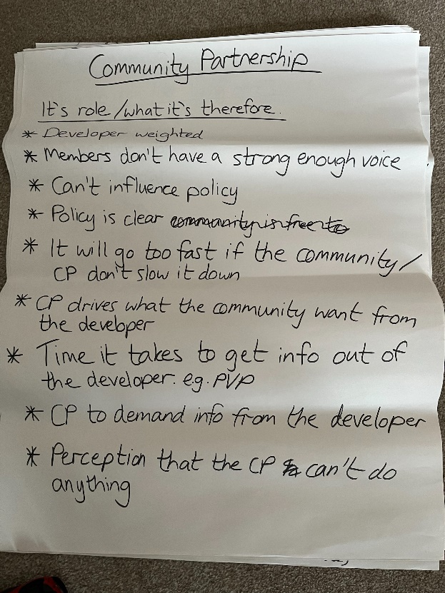

**Feedback from Table 2 facilitated by Maggie Cumming**

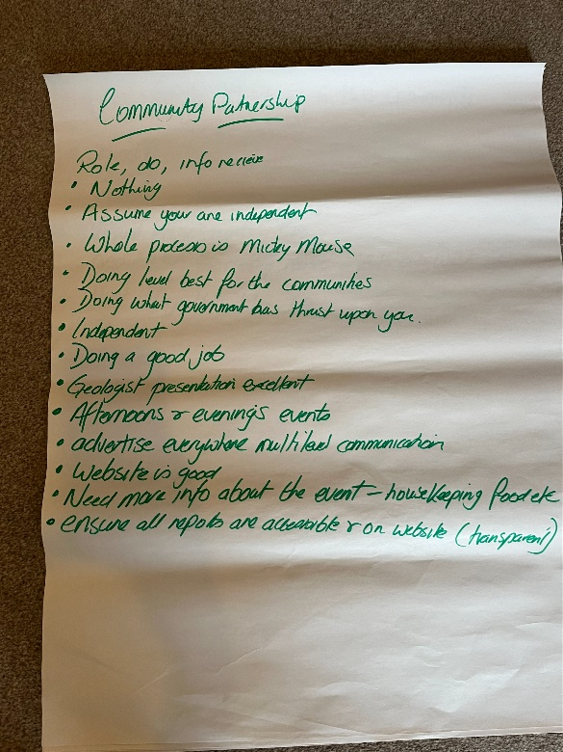

**Appendix 3**

**Flip charts from discussion 3 – Your Community**

**Feedback from Table 1 facilitated by John Sutton**

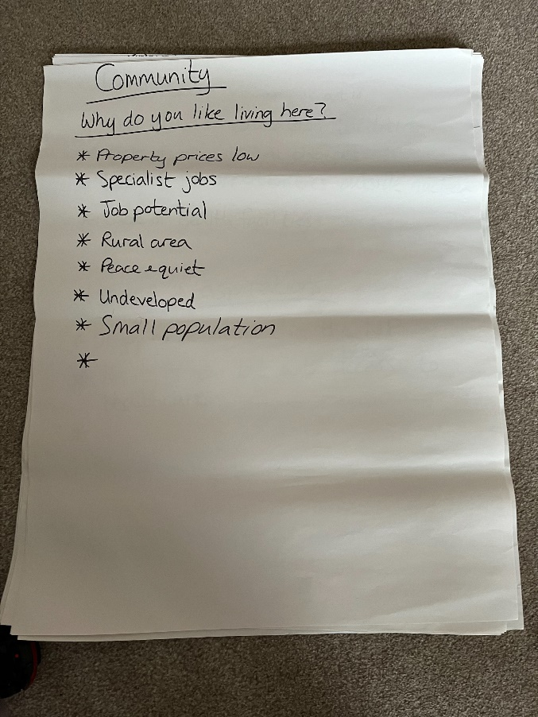 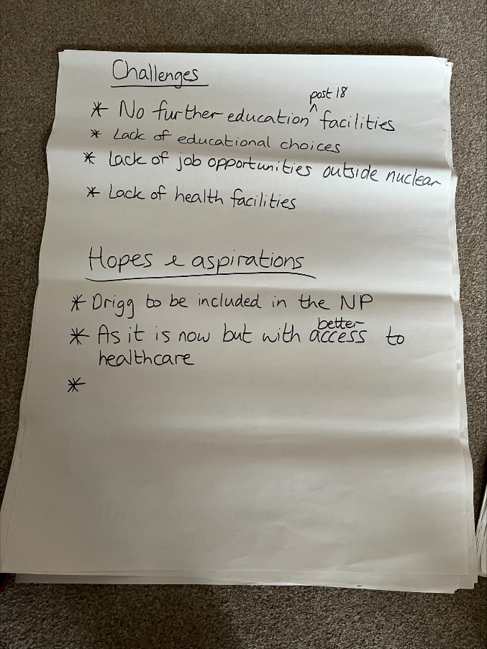

**Feedback from Table 2 facilitated by Maggie Cumming**

