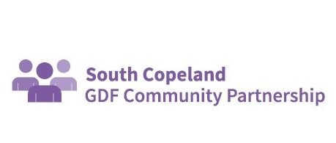
17.01.23

Dear Cllr Blackburn

Thank you for your letter and your interest in the South Copeland GDF Community Partnership.

Members of the Copeland GDF Working Group were consulted in drafting the Community Partnership Agreement, Clause 7 of which makes provision for annual review, for the reasons you suggest. After our first operational year in South Copeland, we are currently in the process of revising our Community Partnership Agreement. This is expected to be signed off at our Community Partnership Meeting on 11.01.23

In terms of membership, the aim is for it to be reflective of the local community in the Search Area. We welcome members with a wide variety of views and being a member of the South Copeland GDF Community Partnership in no way implies a particular stance on GDF.

Thanks again for your letter and continued interest.
Ged McGrath
Chair SCCP

