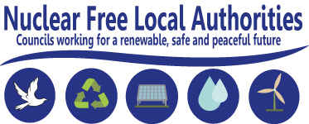

**UK & Ireland NFLA Secretariat**

City Policy

Level 6, Town Hall Extension,

Library Walk, Manchester, M60 2LA

Chair: Councillor David Blackburn Secretary: Richard Outram

Tel: 07583 097793

Email: [richard.outram@manchester.gov.uk](mailto:richard.outram@manchester.gov.uk) Website: <https://www.nuclearpolicy.info>

To the Chairs and members of the GDF Community Partnerships30 November 2022

Dear Chairs and members,

Now that your Community Partnership (CP) is formalised and as you finalise your membership, I am sending you a second letter as Chair of the Nuclear Free Local Authorities relating to the democratisation of the GDF-process.

According to the ‘*Community Guidance’* document published by Radioactive Waste Management (RWM) [now Nuclear Waste Services – NWS], a CP ***‘***will comprise members of the community’(Page 30).

**Revising the Community Partnership Agreement and Code of Conduct**

The guidance states that ‘prospective members will be appointed onto the CP upon signing the Community Partnership Agreement’(CPA)(Page 31) and in addition they are required to sign up to a Code of Conduct.

It seems contrary to the ‘consent-based approach’ that the NWS and government have stated they wish to follow to expect new Community Members to sign up to either document without having been involved in drafting the wording or intent; rather it seems only fair to expect Community Members to have an opportunity to influence these documents if they will be expected to abide by their contents.

**Would your CP agree a schedule of periodic reviews of these documents to enable ‘community members’ to discuss them and consider revisions to the wording, with the first review being set at an early date to enable reflection of the experience of the transition period from Working Group to functional CP?**

**Reassurances that CP members may be opposed to the GDF**

In email exchanges between Mr Jon Collins, Interim Chair of the Theddlethorpe CP, and the Guardians of the East Coast, a campaign group set up by residents to oppose the plans for a GDF, GOTEC sought assurances on the conditions that would apply to their participation in the CP and Mr Collins provided clarification as follows:

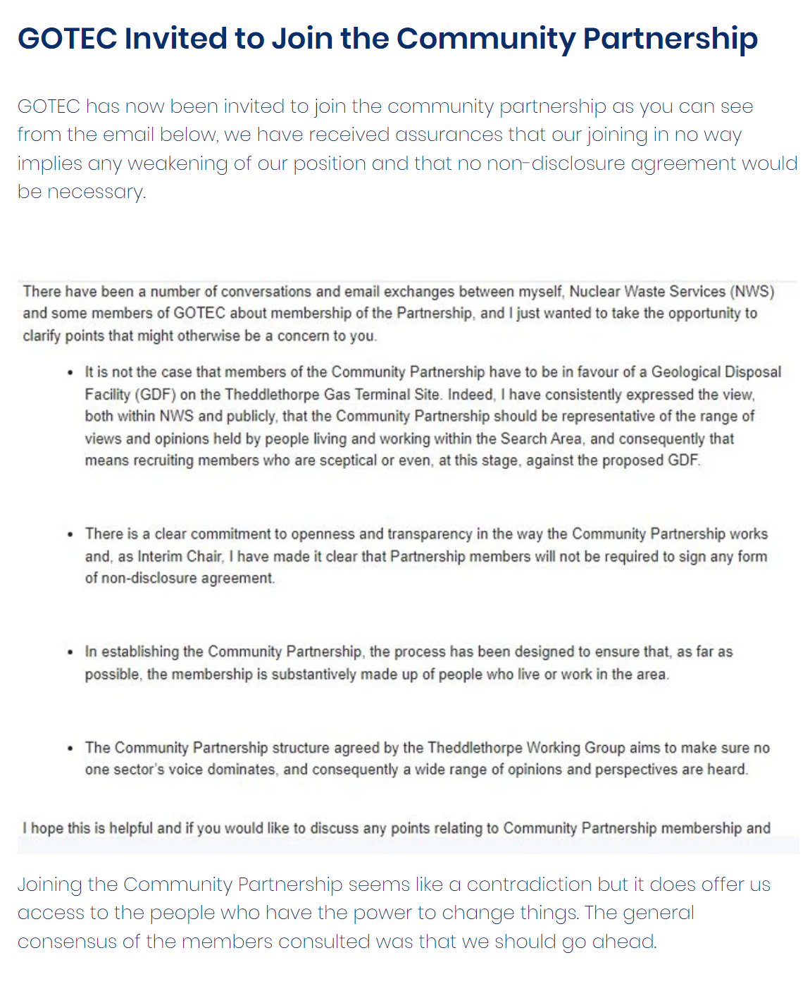

**Would your CP also agree to these points of principle?**

Thank you for considering these points. I look forward to your response which can be furnished by email to the NFLA Secretary, Richard Outram, at [richard.outram@manchester.gov.uk](mailto:richard.outram@manchester.gov.uk)

Yours faithfully,

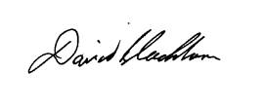

Councillor David Blackburn,

Chair of the NFLA Steering Committee